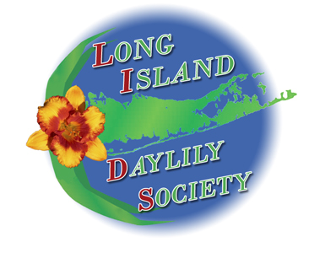
LIDS’ “FUN IN THE SUN!”
Registration for the 2019 Region 4 Annual Meeting
Hosted by the Long Island Daylily Society
Held at: HILTON LONG ISLAND / HUNTINGTON
598 Broad Hollow Road, Melville NY 11747 Phone: 1 631-845-1000
Hiltonlongisland.com

Friday, July 19 – Saturday, July 20, 2019
Your registration includes the Saturday bus tour and four meals: Friday buffet dinner, Saturday grab and go breakfast, Saturday lunch at Planting Fields Arboretum in Oyster Bay, NY, and Saturday evening sit down banquet.
______________________________________________________________________________________
Number Attending: _____$200 (Single)
_____$150 (Youth)
Total Enclosed Payment= $______
(Cancellations received by May 1, 2019 will receive a full refund. May 2- June 1 will receive 50% refund.)
______________________________________________________________________________________

Name 1:________________________________ Name 2:_________________________________
Name 3:________________________________ Name 4:_________________________________

Address: ______________________________City/State/Prov: _________________ Zip code: _______
Home Phone: ___________________________ Cell Phone: ________________________________
E-mail Address: _______________________________________________________________________
Special Needs (Dietary, accessibility, etc.):__________________________________________________
________________________________________________________________________________________

Would you like to attend a Garden Judge Workshop 2 on Sunday, 7/21 from 9:30 – 11:30 AM? ___ Yes
Is e-mail notification confirmation of this registration acceptable to you? ___Yes ___No

Checks payable to: Long Island Daylily Society (Deadline for registrations - June 20, 2019)
Mail to: Joan Turano, Registrar 114 Yale Avenue Oakdale, NY 11769
E-mail: turanojoan@optonline.net Phone (631) 589-2481

You are responsible for your own hotel reservations. The HILTON LONG ISLAND / HUNTINGTON (1 631-845-1000) has a discount room rate of is $165.00 for attendees. Mention “LIDS” when you make your reservation.

Check the LIDS website at: http://longislanddaylily.weebly.com
For more information and a downloadable registration form.

